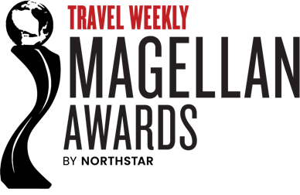

For Immediate Release
Contact: Mary Pat Sullivan, msullivan@northstartravelgroup.com

2025 TRAVEL WEEKLY MAGELLAN AWARDS WINNERS ANNOUNCED
GOLD AND SILVER WINNERS NAMED

Rutherford, NJ (October 9, 2025) – Travel Weekly announced the winners of the 2025 Magellan Awards. With hundreds of entries from across the U.S. and around the world, the Magellan Award winners represent the best in the travel industry and salute the outstanding travel professionals behind it all.

The Magellan Awards honor outstanding design, marketing and services in a broad range of industry segments including Hospitality, Travel Destinations, Cruise Lines, Online Travel Services, Airlines and Airports, Travel Agents and Agencies, Tour Operators and Ground Transportation.

"Each year, I think, 'This will be the year to remember' -- the year that creativity, innovation and inspiration in the entries of the Travel Weekly Magellan Awards has peaked,” said Arnie Weissmann, editor-in-chief of Travel Weekly. “Yet this year – the 18th annual Travel Weekly Magellan Awards – has topped all that has come before. You have to wonder: Can the bar get any higher?"

The Magellan Awards are judged and overseen by a one-of-a-kind panel of top travel professionals representing the best names and most accomplished leaders from the industry. In determining winners, entries do not compete with one another, instead they are judged against a standard of excellence based on the long experience of Travel Weekly. To uphold this high standard of excellence, a category may have multiple winners, or may have no winners at all.
For a complete list of silver and gold winners, please visit www.travelweeklyawards.com.
ABOUT TRAVEL WEEKLY:
Travel Weekly is the most influential provider of news, research, opinion and analysis to the North American travel trade marketplace. It reaches a broad industry audience in print, online and with face- to-face events throughout the year. Travel Weekly is a part of Northstar Travel Group, the leading B-to-B media company providing information and marketing solutions for the global travel industry. Northstar Travel Group is based in Rutherford, NJ, and more information is available at northstartravelgroup.com

About Northstar Travel Group
Northstar Travel Group is the leading business-to-business media company providing information and marketing solutions for the global travel industry. The company owns 14 media brands connecting 1.3M industry professionals through a comprehensive portfolio of digital, social, print and more than 100 events in 13 countries. Northstar Travel Group is based in Rutherford, NJ.

